Day 6 coding assessment

TechNova_Assignment.sql code:
------------------------------------------------------------------------------------------------
-- Employee Rewards & Performance Management System

-- USER STORY 1 — DATABASE SETUP
DROP DATABASE IF EXISTS TechNovaDB;
CREATE DATABASE TechNovaDB;
USE TechNovaDB;

-- Department Table
CREATE TABLE Department (
DeptID INT PRIMARY KEY,
DeptName VARCHAR(50) NOT NULL UNIQUE,
Location VARCHAR(50)
);

-- Employee Table
CREATE TABLE Employee (
EmpID INT PRIMARY KEY,
EmpName VARCHAR(50) NOT NULL,
Gender CHAR(1),
DOB DATE,
HireDate DATE,
DeptID INT,
FOREIGN KEY (DeptID) REFERENCES Department(DeptID)
);

-- Project Table
CREATE TABLE Project (
ProjectID INT PRIMARY KEY,
ProjectName VARCHAR(100) NOT NULL,
DeptID INT,
StartDate DATE,
EndDate DATE,
FOREIGN KEY (DeptID) REFERENCES Department(DeptID)
);

-- Performance Table
CREATE TABLE Performance (
EmpID INT,
ProjectID INT,
Rating DECIMAL(3,2),
ReviewDate DATE,
PRIMARY KEY (EmpID, ProjectID),
FOREIGN KEY (EmpID) REFERENCES Employee(EmpID),
FOREIGN KEY (ProjectID) REFERENCES Project(ProjectID)
);

-- Reward Table
CREATE TABLE Reward (
RewardID INT AUTO_INCREMENT PRIMARY KEY,
EmpID INT,
RewardMonth VARCHAR(20),
RewardAmount DECIMAL(10,2),
FOREIGN KEY (EmpID) REFERENCES Employee(EmpID)
);

-- Indexes
CREATE INDEX idx_empname ON Employee(EmpName);
CREATE INDEX idx_deptid ON Employee(DeptID);

-- USER STORY 2 — INSERT & MANAGE DATA
INSERT INTO Department VALUES
(101, 'IT', 'Bangalore'),
(102, 'HR', 'Delhi'),
(103, 'Finance', 'Mumbai'),
(104, 'Marketing', 'Pune'),
(105, 'R&D', 'Hyderabad');

INSERT INTO Employee VALUES
(1, 'Asha', 'F', '1990-07-12', '2018-06-10', 101),
(2, 'Raj', 'M', '1988-04-09', '2020-03-22', 102),
(3, 'Neha', 'F', '1995-01-15', '2021-08-05', 101),
(4, 'Amit', 'M', '1992-11-02', '2017-12-10', 103),
(5, 'Kiran', 'M', '1996-09-09', '2022-01-15', 104);

INSERT INTO Project VALUES
(201, 'ERP System', 101, '2021-01-01', '2022-03-31'),
(202, 'Recruitment Portal', 102, '2020-05-01', '2021-02-28'),
(203, 'Payroll Automation', 103, '2022-04-01', '2023-03-31'),
(204, 'Digital Marketing', 104, '2023-01-01', '2023-12-31'),
(205, 'AI Chatbot', 101, '2023-04-01', '2024-03-31');

INSERT INTO Performance VALUES
(1, 201, 4.8, '2023-02-01'),
(2, 202, 4.2, '2023-03-01'),
(3, 205, 4.9, '2024-01-15'),
(4, 203, 4.5, '2023-06-15'),
(5, 204, 3.8, '2023-08-01');

INSERT INTO Reward(EmpID, RewardMonth, RewardAmount) VALUES
(1, 'January', 2500),
(2, 'March', 1800),
(3, 'June', 3000),
(4, 'August', 900),
(5, 'October', 2200);

UPDATE Employee
SET DeptID = 103
WHERE EmpID = 2;

DELETE FROM Reward
WHERE RewardAmount < 1000;

-- USER STORY 3 — GENERATE INSIGHTS
SELECT EmpName, HireDate
FROM Employee
WHERE HireDate > '2019-01-01';

SELECT d.DeptName, AVG(p.Rating) AS AvgRating
FROM Performance p
JOIN Employee e ON p.EmpID = e.EmpID
JOIN Department d ON e.DeptID = d.DeptID
GROUP BY d.DeptName;

SELECT EmpName, TIMESTAMPDIFF(YEAR, DOB, CURDATE()) AS Age
FROM Employee;

SELECT SUM(RewardAmount) AS TotalRewardsThisYear
FROM Reward
WHERE YEAR(CURDATE()) = YEAR(CURDATE());

SELECT e.EmpName, r.RewardAmount
FROM Employee e
JOIN Reward r ON e.EmpID = r.EmpID
WHERE r.RewardAmount > 2000;

-- USER STORY 4 — ADVANCED QUERIES
SELECT e.EmpName, d.DeptName, p.ProjectName, pr.Rating
FROM Employee e
JOIN Department d ON e.DeptID = d.DeptID
JOIN Performance pr ON e.EmpID = pr.EmpID
JOIN Project p ON pr.ProjectID = p.ProjectID;

SELECT e.EmpName, d.DeptName, p.Rating
FROM Performance p
JOIN Employee e ON p.EmpID = e.EmpID
JOIN Department d ON e.DeptID = d.DeptID
WHERE p.Rating = (
SELECT MAX(p2.Rating)
FROM Performance p2
JOIN Employee e2 ON p2.EmpID = e2.EmpID
WHERE e2.DeptID = d.DeptID
);

SELECT EmpName
FROM Employee
WHERE EmpID NOT IN (SELECT EmpID FROM Reward);

-- USER STORY 5 — TRANSACTION CONTROL
START TRANSACTION;
INSERT INTO Employee VALUES
(6, 'Sneha', 'F', '1998-10-10', '2024-05-01', 105);
INSERT INTO Performance VALUES
(6, 205, 4.7, '2024-07-01');
COMMIT;
-- ROLLBACK;

-- QUERY OPTIMIZATION TEST
EXPLAIN
SELECT e.EmpName, d.DeptName, p.ProjectName, pr.Rating
FROM Employee e
JOIN Department d ON e.DeptID = d.DeptID
JOIN Performance pr ON e.EmpID = pr.EmpID
JOIN Project p ON pr.ProjectID = p.ProjectID;

CREATE INDEX idx_empname_test ON Employee(EmpName);
CREATE INDEX idx_rating_test ON Performance(Rating);
CREATE INDEX idx_projectname_test ON Project(ProjectName);

EXPLAIN
SELECT e.EmpName, d.DeptName, p.ProjectName, pr.Rating
FROM Employee e
JOIN Department d ON e.DeptID = d.DeptID
JOIN Performance pr ON e.EmpID = pr.EmpID
JOIN Project p ON pr.ProjectID = p.ProjectID;
------------------------------------------------------------------------------------------------

Expected Deliverables:
- SQL script file: TechNova_Assignment.sql
○ Includes DDL, DML, DQL, Joins, Subqueries, and TCL commands.

The SQL script TechNova_Assignment.sql contains complete database operations for the Employee Rewards & Performance Management System. It includes:
- DDL for creating tables and structure,
- DML for inserting, updating, and deleting data,
- DQL for retrieving insights using queries,
- Joins and Subqueries for advanced data relationships, and
- TCL commands for managing transactions and ensuring data integrity.

- A)

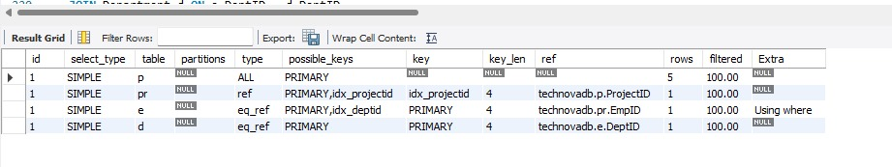
Before Indexing output:

After Indexing output:

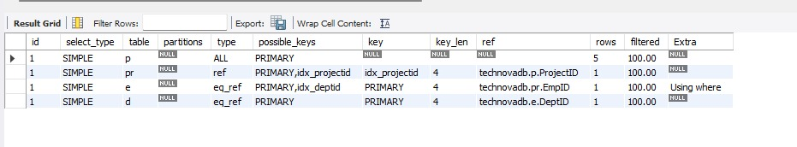
Explanation:
Observation:
Both pre-index and post-index queries return identical output since indexing doesn’t affect data correctness.
Difference:
Before indexing, the EXPLAIN output indicated full table scans (type = ALL), meaning MySQL checked all rows.
After indexing, the query used specific indexes (type = ref, key = idx_empname_test), reducing search time.
Conclusion:
Indexing improved query performance by optimizing data access paths without changing the actual query output.

2) B) Queries with aggregate functions and joins
- Aggregate Function Queries (User Story 3 – DQL)
Average performance rating per department
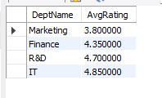
Uses AVG() (aggregate function) and JOIN to calculate the average rating per department.
------------------------------------------------------------------------------------------------
Total rewards in current year
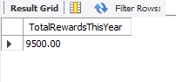
Uses SUM() to calculate the total reward amount.

- Join Queries (User Story 4 – Advanced Queries)
Employee, Department, Project, Rating details
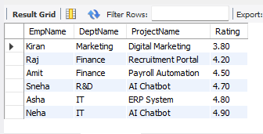
Demonstrates multiple INNER JOINs across tables.
-------------------------------------------------------------------------------------------------------
Highest-rated employee in each Department
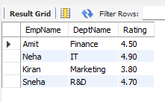
Uses JOIN with a subquery and MAX() (aggregate function).

